2022 APIA Annual Conference

6800 Governors West, NW Huntsville, Alabama 35806

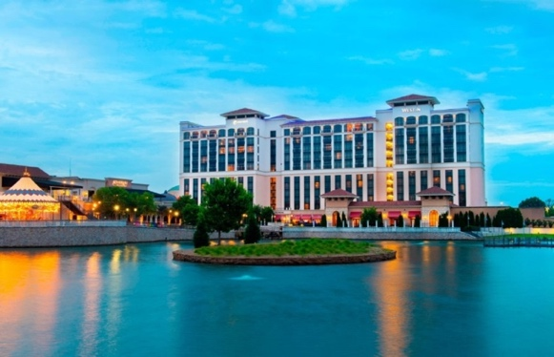
Sept. 14th,2022

APIA Board of Directors Meeting 9 AM to 10 AM (Restaurant will be announced)

10:00A.M. - 12:00 P.M. Attendee sign in

12:00 P.M - 12:50 P.M. Welcome from the President and Introduction of Board and Vendors

1:00 P.M. - 1:50 P.M. Class: Speaker Chris Browning - Technical Threats and Mitigation Tools
20 min Break

2:10 P.M. - 3:00 P.M. Class: Speaker Rick Miller- Re-Investigating Murder Cases.

10 min Break

3:10 P.M - 4:00 P.M. Class: Speaker Rick Miller- Re-Investigating Murder Cases continued.

4:10 P.M - 5:00 P.M. Class: Speaker Stephen Shaw – Ethics

5:00 P.M.-5:10 P.M. Door prize drawing.

20 min break, get checked in to your rooms if you haven’t already done so and get back down for the reception.

Vendor Sponsored Social 5:30 P.M. - 7:30 P.M. Hors-d'oeuvre will be served, and a cash bar will be provided. Live entertainment by Patrick Barnett. Meet new people and catch up with old friends!

2022 APIA Annual Conference
Sept. 15Th 2022

7:00 A.M. - 8:00 A.M. Breakfast Provided In main conference room. Misc. announcements.

8:00 A.M. - 8:50 A.M. Class: Speaker Kelly Riddle speaking on Military Investigations.
This class will discuss how to identify fake Navy Seals, ways to identify if a person has been in the military and types of records available.
8:00 A.M. - 8:50 A.M. Break off Class: Speaker. Jeff Hammock. Rule 4 (process service)

9:00 A.M.- 9:50 A.M. Class: Speakers Rick Fernambucq and Charles Dunn,
“How To Get What We Need: Private Investigation from a Divorce Lawyer’s Perspective.”

20 min. Break

10:10 A.M. - 11:00 A.M. Class: Speaker Jay Jacome speaking on Essentials of Criminal Defense Investigations.
10:10 A.M. – 11:00 A.M. Break off Class: Chris Browning - Apple Air Tags tracking

11:00 A.M. - 11:50 A.M. Class: Speaker Charles Hopkins-The Art of Investigative Interviews.

12:00 P.M. Lunch Provided

1:00 P.M. - 1:50 P.M. Class: Speaker Michelle Riley-Notary Update for PI's

2:00 P.M. - 2:50 P.M. Class: Speaker Kelley Riddle speaking on Fraud investigations.
This class will identify the latest trends and types of fraud and how to conduct the investigation into advanced types of fraud

2:00 P.M. – 2:50 P.M. Break off Class. Speaker: Jim Casteel – Covert and Body worn camera options, restrictions, precautions, and solutions.
20 min. Break

3:10 P.M. - 4:00 P.M. Class: Speaker Tim O’Rourke - Surveillance Detection Route (SDR)

4:00 P.M.- 5:00 P.M. APIA Members Meeting (voting on Board members and New Business, planning of Christmas Party)

